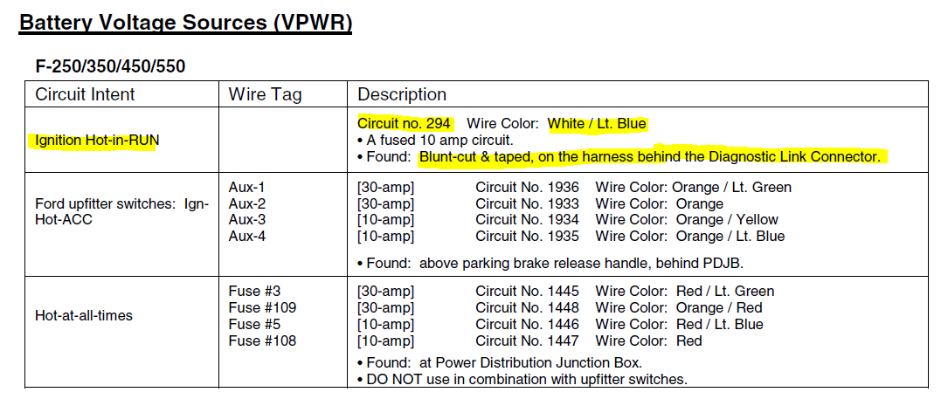
2005 Ford Customer Access Circuits

